## composer require slim/slim "^3.0"

1. 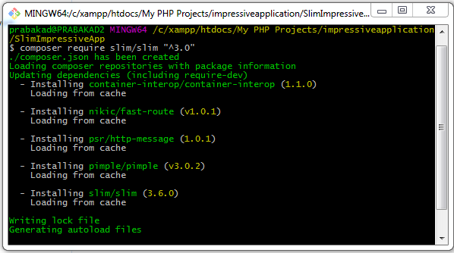

## composer require illuminate/database

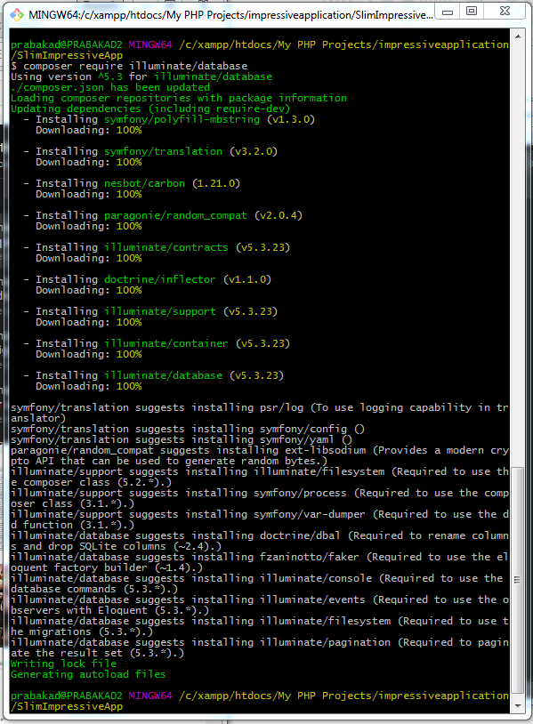

## $ composer require slim/twig-view

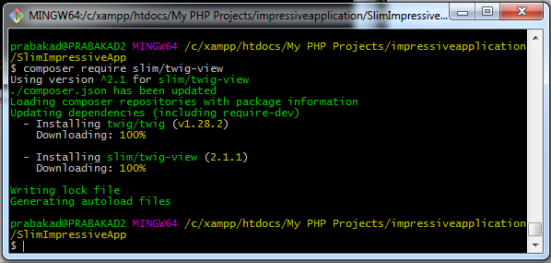

## $ composer dump-autoload –o

